Job Mashup Website
Milestone 1 Part A

Jacob Barrick
Colin Blower
Honming Chen
Curtis Davis
Victor Frandsen
Sam Lanzo
Andrew Miller
Yu-Ching Wang

October 6, 2012
CS 160
Group 2: G²
Assigned domain:
Jobs Mashup

Feature Summary Table
Features | Why is it useful to users | Why is it innovative? | Matching core requirement | Team Composition
Filter by experience and or education | Provide results for a type of position based on user’s Education and Experience | Avoid results not matching user’s experience and skills | #3 | Curtis Davis
Search by Interactive Map | See where the jobs are on the map | It is easier to check for jobs in cultural-rich regions or locate other business nearby | #3 | Sam Lanzo
Search by Location | Provide results based on location | Core feature: results can be filtered to match users desired location | #2 | Hon-ming Chen
Search by Job Title | Provide relevant jobs by title | Core feature: results can be filtered to match users desired job title | #2 | Colin Blower
Search by Job Type | Provide relevant jobs by type | Core feature: results can be filtered to match users desired type | #2 | Victor Fransen
Search by Salary | Provide relevant jobs by salary | Core feature: results can be filtered to match users desired salary | #2 | Andrew Miller

Introduction

Websites to be aggregated in this spec
- www.dice.com
- www.monster.com
- www.linkup.com
- www.careerbuilder.com

Each day countless number of people search for jobs. It is a difficult process since jobs are not located in a central database. Some companies will post their available positions on one job board but might not post the position on a different job board. It is up to the user to search all job boards and filter through the common jobs that appear on all websites in order to find a good match.

This is where our job mashup website comes in. The website will search other jobs boards and centralize the jobs in one location. Currently, the features include search by location, via movable map, job type and job title. In addition, the user can filter by salary, education, and experience. More features will be added later on but the current features will already allow users of the mashup website access to multiple job websites at one. By searching for common input, the mashup website will be able to query other websites for relevant jobs.

Website: coming soon…

Common input and output

Common Input Summary Table
Input variable | Format in www.Dice.com | Format in www.Monster.com | Format conversion | Format in mashup site
Location | San+Jose%2C+CA | San-Jose_2C-CA | needed | where= San-Jose_2C-CA
Job Title | Principal+Engineer | Principal-Engineer | needed | q=Principal-Engineer

Common output Summary Table
Output variable | Format in www.Dice.com | Format in www.Monster.com | Format conversion | Format in mashup site
Location | San Francisco, CA | San Francisco | needed | San Francisco, CA
Job Title | Software Engineer | Software Engineer | Not needed | Software Engineer
Job Type | Full-Time | Full-Time | Not needed | Full-Time
Salary | $100,000 | $100,000 | Not needed | $100,000
Experience | 5-8 years | 5-8 years | Not needed | 5-8 years
Education | BA,BS in CS | BA,BS in CS | Not needed | BA,BS in CS

Additional input and output variable/format (describe below in a list)

Proposed Features

Feature #1 Filter by Education and/or Experience (Common Requirement 3)

Filter by Education and/or Experience
- After a user searches for jobs they can filter those results based on the required education and/or experience required.

How it will be useful to users
A new feature of the “experience/education required” output will allow the user to visually see the experience or educational requirements for the positions displayed. This is more user-friendly because often times users will not be interested in jobs outside of their qualifications. With this output feature, our mash-up website will be able to personalize the results more effectively than other sites such as dice.com and monster.com. Additionally, the user will have the option of sorting jobs by experience/education requirements (e.g. no college degree, AA degree, Bachelor's degree, Master's degree).

Why this is Innovative
The result information on our mash-up site will include but is not limited to: job title, company name, location, experience/education requirements, and a brief job description. Dice.com and Monster.com both simply list the job title and the company; however, this information is disorganized and useless if the user is looking for a particular position close-by and would like to scroll through the locations available.

The results will be displayed in an organized fashion without extra irrelevant information. The job title will be displayed first, with the location and company name below it. Below this information will be the experience/education requirements in bold lettering, followed by a brief description of the job opportunity. These results will be 10 to a page with the most relevant towards the top.

These specific results displayed in an organized fashion will allow the user to swiftly scroll through the jobs in search of one that catches their eye. A display of the requirements may also inform the user of any opportunities that just barely fit his or her qualifications and/or opportunities that are a perfect fit for what he or she is looking for.

This feature may be achieved by locating the job listing on a particular website, searching for the keywords “requirements, qualifications” and retrieving the content thereafter to output on our mash-up site. This feature may be implemented much similar than the core feature of the job description itself, with only minor changes to the location of where the content would be held on the website hosting the job listing. This feature is innovative, simple, and user-friendly.

URL References
Dice.com URL: http://seeker.dice.com/jobsearch/servlet/JobSearch?op=300&N=0&Hf=0&NUM_PER_PAGE=30&Ntk=JobSearchRanking&Ntx=mode+matchall&AREA_CODES=&AC_COUNTRY=1525&QUICK=1&ZIPCODE=&RADIUS=64.37376&ZC_COUNTRY=0&COUNTRY=1525&STAT_PROV=0&METRO_AREA=33.78715899%2C-84.39164034&TRAVEL=0&TAXTERM=0&SORTSPEC=0&FRMT=0&DAYSBACK=30&LOCATION_OPTION=2&FREE_TEXT=Java&WHERE=San+Jose%2C+CA

Monster.com URL: http://jobsearch.monster.com/search/Java_5?where=San-Jose__2C-CA

linkup.com URL: http://www.linkup.com/b/Java-jobs.html?l=san+jose%2C+CA

Careerbuilder.com URL: http://www.careerbuilder.com/Jobseeker/Jobs/JobResults.aspx?IPath=QH&rs=&_ctl0%3ANavBar1%3AucQuickBar%3As_rawwords=Java&_ctl0%3ANavBar1%3AucQuickBar%3As_freeloc=San+Jose%2C+CA&_ctl0%3ANavBar1%3AucQuickBar%3As_jobtypes=ALL&qsbButton=Find+Jobs

Feature #2 Search via Movable Map (Common Requirement 3)

Search via Movable Map
- A map will appear after the user searches for jobs.
- They can then move it around and get jobs that are located within the map

How it will be useful to users
- Feature is similar to a feature on yelp.com, which allows the user to interact with a map and redo their search in that area

Why this is Innovative
This feature falls under the domain requirement c3, being an additional feature that is not implemented on the mashed-up sites. This is a useful feature because searching by city/zip code can be too narrow of a search. Searching by geographic area allows nearby cities to all be searched concurrently, and gives the user a better approximation of commute time to/from work.

URL References
http://www.yelp.com/search?cflt=restaurants&find_desc=&find_loc=San+Jose%2C+CA)

Feature #3 Search via Location (Common Requirement 2)

Search via Location
- A location textbox will exist on the home page and results page
- The user can search by city, state, or zip code
- The user can refine their search based on radius of the location entered

How it will be useful to users
- Location is useful because the user wants to have a reasonable commute to their job.

Why this is Innovative
Searching by location is a core feature needed in every job board website. This is user friendly because the majority of users will want the ability to narrow their search by location. The user will also be able to set a radius around their location of choice to either expand or narrow their search.

Job posts by location can be retrieved by creating a custom URL for each website. In the Monster.com example above the keyword/value pair is “where” and “San-Jose_2C-CA”. Knowing the proper keyword/value pair for the other websites will allow us to query their databases for jobs by location. The websites can take a zip code, city, state, or city and state combination. The city and state combination does not have to be a valid combination. If the city and state are not a valid combination then the search will be carried out for both city and state separately. The location field is option, if it is left blank than a search will be done for all jobs in America.

As the various websites are queried we will need to store each individual job post. The websites source file can be parsed for the job post. All relevant information such as job title, type, location, description, etc. will be stored in a database. As the query is building up the database, it should also detect duplicates. One way we can detect duplicates is by matching the job post URL. If the job post URL match, then the query system will not add the job post to the database.

After the query system finishes, it will rank the jobs giving higher rankings to the jobs closest to the location entered. Jobs older than 30 days will be given a lower rank with progressively lower rankings as the job gets older.

The user will have the ability to filter their location by radius. A dropdown menu will allow the user to filter their results by 10, 20, 50, and 100+ miles. If the user filters by radius, the query system will only display job post within the radius. If no jobs are found, the user will see an empty results page along with an error message.

URL References
Dice.com URL:
http://seeker.dice.com/jobsearch/servlet/JobSearch?op=300&N=0&Hf=0&NUM_PER_PAGE=30&Ntk=JobSearchRanking&Ntx=mode+matchall&AREA_CODES=&AC_COUNTRY=1525&QUICK=1&ZIPCODE=&RADIUS=64.37376&ZC_COUNTRY=0&COUNTRY=1525&STAT_PROV=0&METRO_AREA=33.78715899%2C-84.39164034&TRAVEL=0&TAXTERM=0&SORTSPEC=0&FRMT=0&DAYSBACK=30&LOCATION_OPTION=2&FREE_TEXT=Java&WHERE=San+Jose%2C+CA

Monster.com URL:
http://jobsearch.monster.com/search/?where=San-Jose__2C-CA

Linkup.com URL:
http://www.linkup.com/results.php?l=san+jose%2C+ca

Careerbuilder.com URL:
http://www.careerbuilder.com/Jobseeker/Jobs/JobResults.aspx?IPath=QH&rs=&_ctl0%3ANavBar1%3AucQuickBar%3As_rawwords=&_ctl0%3ANavBar1%3AucQuickBar%3As_freeloc=san+jose%2C+ca&_ctl0%3ANavBar1%3AucQuickBar%3As_jobtypes=ALL&qsbButton=Find+Jobs

Feature #4 Search by Job Title (Common Requirement 3)

Search by Job Title
- A job title textbox will appear on the home page and results page
- The user can enter a job title or leave it blank when searching for jobs

How it will be useful to users
- The user can search for jobs that match their skill set

Why this is Innovative
A core feature

URL References
Monster.com URL:
http://jobsearch.monster.com/search/Principal-Engineer_5?

Dice.com URL:
http://seeker.dice.com/jobsearch/servlet/JobSearch?op=300&N=0&Hf=0&NUM_PER_PAGE=30&Ntk=JobSearchRanking&Ntx=mode+matchall&AREA_CODES=&AC_COUNTRY=1525&QUICK=1&ZIPCODE=&RADIUS=64.37376&ZC_COUNTRY=0&COUNTRY=1525&STAT_PROV=0&METRO_AREA=33.78715899%2C-84.39164034&TRAVEL=0&TAXTERM=0&SORTSPEC=0&FRMT=0&DAYSBACK=30&LOCATION_OPTION=2&FREE_TEXT=Principal+Engineer&WHERE=

Indeed.com URL
http://www.indeed.com/jobs?q=Principal+Engineer&l=

Feature #5 Search by Job Type (Common Requirement 3)

Search by Job Type
- After a user searches for jobs
- They can refine their search based off Job Type

How it will be useful to users
- Users will want to search by jobs based on their time commitment

Why this is Innovative
Both monster and dice offer the ability to search for jobs of a specific type, i.e. full-time or part-time. Both sites, however, differ on types offered. Where monster offers, intern, temp, and other, dice offers none of those, yet has more diverse contract options, which may be equivalent in some sense, but it is not clear.

URL References
http://jobs.careerbuilder.com/jobseeker/jobs/jobresults.aspx?as%3AMXJobSrchCriteria_JobQueryType=RAD&as%3Ach=al&as%3AMXJobSrchCriteria_QuerySrc=AdvSearchFrm&as%3AIPath=QA&as%3As_rawwords=&as%3As_use=ALL&as%3As_freeloc=&as%3As_freeloc=&as%3As_freeloc=&as%3As_radius=30&as%3As_freshness=30&as%3AMXJOBSRCHCRITERIA_Industries=&as%3As_jobtypes=ALL&as%3As_jobtypes=ALL&as%3As_jobtypes=ALL&as%3As_education=DRNS&as%3As_includelowereducationvalues=YES&s_includelowereducationvalues_hidden=&as%3As_emptype=JTFT&as%3As_emptype=JTCT&as%3As_emptype=JTPT&as%3As_emptype=JTIN&as%3As_emptype=JTSE&as%3As_paylow=70&as%3As_payhigh=gt120&as%3Aexkw=&as%3Aexjl=&as%3Aexcn=&SearchBtn=Find+Jobs+%C2%BB

Feature #6 Search by Salary (Common Requirement 3)

Search by Salary
- After a user searches for jobs
- They can refine their search based off desired salary

How it will be useful to users
- Searching by Salary is not a core feature, but is a nice advanced search feature, particularly for inexperienced users who want to search for low paying entry level jobs, and very experienced users looking for only high paying jobs.

Why this is Innovative
When a user goes to the advanced search page, they have options to enter minimum and maximum salary. The user can choose to enter just minimum, just maximum, both, or neither. If the user enters neither, no searching by salary is done. If the user does enter values, only sites containing salary information are searched. Searching by salary on sites that do have a salary feature is done by sending a request to each site with a URL containing the requested salary information. Examples of the URL structure for two sites with salary information can be found in the URL Analysis section.

After the request is sent to each site, a response should be received from each site containing the job listings. Some sites only display a certain amount of job listings per page, so additional requests may need to be done in order to get all listings. Each response will then be parsed in order to strip out and store the job information. Each time a job is added, it will check against the jobs already stored to avoid duplicate postings. Once all job listings have been stored, a response is created and sent to the user containing all the job listings that meet their selected salary criteria.

URL References
Careerbuilder.com: http://jobs.careerbuilder.com/jobseeker/jobs/jobresults.aspx?as%3AMXJobSrchCriteria_JobQueryType=RAD&as%3Ach=al&as%3AMXJobSrchCriteria_QuerySrc=AdvSearchFrm&as%3AIPath=QA&as%3As_rawwords=&as%3As_use=ALL&as%3As_freeloc=&as%3As_freeloc=&as%3As_freeloc=&as%3As_radius=30&as%3As_freshness=30&as%3AMXJOBSRCHCRITERIA_Industries=&as%3As_jobtypes=ALL&as%3As_jobtypes=ALL&as%3As_jobtypes=ALL&as%3As_education=DRNS&as%3As_includelowereducationvalues=YES&s_includelowereducationvalues_hidden=&as%3As_emptype=JTFT&as%3As_emptype=JTCT&as%3As_emptype=JTPT&as%3As_emptype=JTIN&as%3As_emptype=JTSE&as%3As_paylow=50&as%3As_payhigh=70&as%3Aexkw=&as%3Aexjl=&as%3Aexcn=&SearchBtn=Find+Jobs+%C2%BB

Monster.com: http://jobsearch.monster.com/search/?salmin=50000&saltyp=1
Use Cases
Use Case ID | G2-M1-F1
Use Case Name | Output Jobs With Particular Job Requirements (Experience, Education)
Created By | Curtis Davis
Actor | User
Description and  Event flow | Results will display for the user, including the job title, company name, location, experience/educational requirements of the position, and a brief job description.  - User will enter input for job title and location.  - Drop down menu will allow auto-complete to guess what the user would like to search by.  - User will click “search” when he or she is ready to continue to the results.  - Results be displayed by relevance with the following information:  - Job title  - Company name  - Location  - Experience/Education requirements  - Brief job description
Pre-conditions | - User has completed all input fields as required
Post-conditions | - User can click the job title as a hyperlink to visit the actual job posting
Input | - Job title – ASCII characters only  - Location – Must be an actual city and state.
Output | - Results relevant to the inputs with the above information included.
Includes
Notes | - If any required field is blank, notify the user that more information is needed to personalize the search results.

Use Case ID | G2-M1-F2
Use Case Name | User Searches Jobs Via Movable Map
Created By | Samuel Duckworth-Lanzo
Actor | User
Description and  Event flow | A user wants to do a search by location.  - User checks 'Redo Search When Map Moved' check-box.  - Location search is redone based on area visible on map.  - Job listing is updated with new search results.
Pre-conditions | - User has already done a search by area.
Post-conditions | - Displayed job positions reside within map area.
Input | Required  - Check 'Redo Search When Map Moved' check-box.
Output | - Displayed job listings contain only jobs within the map's area.
Includes
Notes | - Requires all job listings to have a location associated with them.

Use Case ID | G2-M1-F3
Use Case Name | Search jobs based on location
Created By | Hon-ming Chen
Actor | User
Description and  Event flow | A user will search for jobs based on location  - User clicks on location textbox  - User enters a city and state separated by a comma or enters zip code  - User clicks “Search” button
Pre-conditions | - User is on the website and has entered a location or no location.
Post-conditions | - User is shown a list of job titles as hyperlinks to visit the actual job posting
Input | Optional  - Location – city and state or zip code  - Job Title – alphanumeric characters plus spaces, periods, hyphens, apostrophes and underscores.
Output | - A results page is shown with jobs near the location entered  - Results page will be filtered by job type if that textbox is filled
Includes
Notes | - If no location is given, search for jobs throughout America  - If state and city is the wrong combination, match search by city name

Use Case ID | G2-M1-F4
Use Case Name | Output jobs with particular title
Created By | Colin Blower
Actor | User
Description and  Event flow | A new user begins to search the site.  - User clicks search box.  - User enters a job title to search for.  - Auto-completion suggests common job titles.  - User finishes entering a job title and clicks search  - A new results page is displayed.  - The results page will include a count of matching job postings  - Results be displayed by relevance with the following information:  - Job title  - Company name  - Location  - Experience/Education requirements  - Brief job description
Pre-conditions | - User has completed the job title field as required
Post-conditions | - User can click the job posting link to visit the actual job posting  - User can see a job count for the job title
Input | Required  - Job Title – alphanumeric characters plus spaces, periods, hyphens, apostrophes and underscores.
Output | - Results relevant to the input job title  - A count of results displayed on the page
Includes
Notes | - If any required field is changed to blank or any input is ill-formatted, an error message is written to the form and the Employer is prompted to revise it and resubmit.

Use Case ID | G2.M1.F5
Use Case Name | Output jobs by type
Created By | Victor Frandsen
Actor | User
Description and  Event flow | A new user begins to search the site.  - User searches for job type  - User clicks on ‘Advanced Search’ link  - Advanced search page is displayed  - User checks ‘full-time’ box  - User clicks ‘search’  - Search page is displayed
Pre-conditions | - User is at home page.
Post-conditions | - Only jobs of type ‘full-time’ are displayed on search page
Input | - None
Output | - List of full-time jobs
Includes
Notes | If no boxes are checked, the search should return all job types.  More than one box can be checked.  This use case should apply to any or all of the following job types.  Full-time, Part-time, intern, contract, temp, other.

Use Case ID | G2-M1-F6
Use Case Name | Search by Salary Range
Created By | Andrew Miller , Victor Frandsen
Actor | User
Description and  Event flow | - User clicks on ‘Advanced Search’ link  - Advanced search page is displayed  - User may specify minimum range  - User may specify maximum range  - User clicks ‘search’  - Results page is displayed
Pre-conditions | - Employer is at home or advanced search page
Post-conditions | - Only job listings in the specified pay range are shown
Input | Optional  - Minimum Salary  - Maximum Salary
Output | - List of job listings in the pay range
Includes
Notes

Use Case Diagram
Feature 1
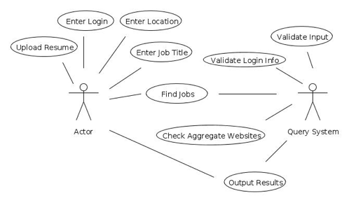

Feature 2
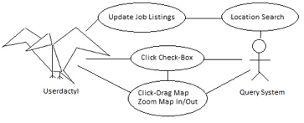
Feature 3
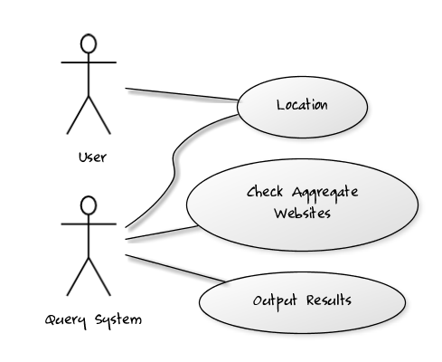
Feature 6
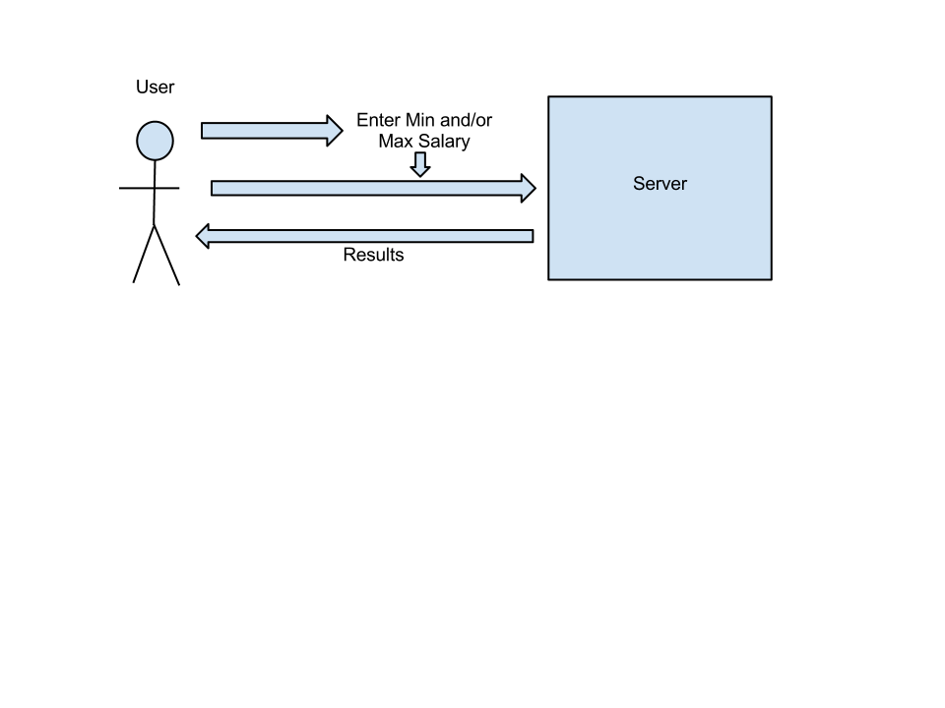
Site Map Flowcharts

